Improving SIFT Features / Finding Planes in Hallways

Christer Gustavsson, Anthony Hui, and Michael Turitzin
(Project Advisor: Gary Bradski)

Abstract

Due to a change in focus in our project near the end of the quarter, we have focused on two separate topics. The first goal of our project was to implement, simplify, and improve the Scale Invariant Feature Transform (SIFT) algorithm developed by David Lowe (Lowe, 1999 and 2003). Among other accomplishments part of our project, we have fully implemented Lowe’s several-stage object recognition algorithm and tested object recognition on a precisely-acquired database of images we obtained over the course of the project. Because Lowe’s keypoint generation code was made available midway through our project, our goal was changed near the end of the quarter to that of finding planes in hallways using SIFT feature matches between image pairs. We have implemented an algorithm that finds planar homographies between two images using such feature matches and a RANSAC-based scheme to find likely candidates.

Introduction

The Scale Invariant Feature Transform (SIFT) was introduced by David Lowe in (Lowe, 1999). SIFT is a method for extracting distinctive invariant features from images that can be used to perform reliable matching between different images of the same object or scene. Because of its computational efficiency and robustness, the SIFT algorithm has led to significant advances in computer vision.

The major problem with SIFT is that the algorithm is not crisply defined by Lowe’s papers and has lots of free parameters; the information Lowe provides is sometimes vague and not complete, leaving lots of implementation details to be filled in. When our project began, there was no source code available to show how the algorithm is really implemented; our intent was originally to do the implementation on our own using incomplete MATLAB code from Intel as a base. We wanted to implement Lowe’s algorithm roughly as he has defined it and then to make simplifications and improvements to it, specifically with regard to illumination invariance.

We did make significant progress in these areas, some of which was thrown out when Lowe’s keypoint generation code was released, and some of which was kept (namely, the object recognition part). Our implementation of Lowe’s three-stage object recognition algorithm, which involves keypoint matching, a Hough transform, and solving for affine parameters, is fully functional. We took a database of training images and scene images over varying parameters such as angle, distance, and illumination to test our implementation of Lowe’s algorithm.

Our goals were changed abruptly midway through our project due to the sudden availability of Lowe’s keypoint generation code. We first decided to scrap our implementation of this part of Lowe’s algorithm and focus solely on improving Lowe’s code and working on object recognition. Later, Gary, our project advisor, suggested in a meeting that we turn our focus to something completely different: using SIFT features to find planes in consecutive images taken while moving down hallways. Work has already been done in finding planes visible in sequences of images, but to our knowledge, SIFT features have not been used for this purpose. Because of the impressive robustness of SIFT features in object recognition and other applications, it was suggested that we use them for plane finding using an algorithm that will be spelled out in the Approach section. Although we have not completed all of our goals for this section of the project due to its extremely short timeframe, we have implemented the plane-finding algorithm and obtained useful results on sample hallway images we have collected.

A detailed description of our work and results in both of these areas can be found in the Results section.

Algorithms Used (Approach)

The algorithms forming the backbone of the topics of our project were Lowe’s SIFT algorithm for keypoint generation and object recognition, and our plane detection algorithm. They are described below.

Lowe’s SIFT algorithm

Lowe outlines his algorithm in detail in (Lowe, 2003), so we will not explain it in depth. In a nutshell, Lowe’s algorithm finds stable features over scale space by repeatedly smoothing and downsampling an input image and subtracting adjacent levels to create a pyramid of difference-of-Gaussian images. The features the SIFT algorithm detects represent minima and maxima in scale space of these difference-of-Gaussian images. At each of these minima and maxima, a detailed model is fit to determine location, scale and contrast, during which some features are discarded based on measures of their (in)stability. Once a stable feature has been detected, its dominant gradient orientation is obtained, and a keypoint descriptor vector is formed from a grid of gradient histograms constructed from the gradients in the neighborhood of the feature.

Object recognition between images is performed using a nearest-neighbor indexing method for keypoint matching, followed by a Hough transform that finds keypoints that agree on potential object poses, and finally a solution for affine parameters, which determines the specific location and orientation of each recognized object.

Plane detection algorithm

The algorithm described here was suggested by our project advisor Gary and is very similar to that outlined in (Vincent and Laganiere, 2001). Our goal is to recover one (3x3) homography matrix for each plane present in the scene. The homography matrix relates the matching feature point pairs in the two different images that lie on the same plane. The following are the steps of the algorithm that we employed:

- SIFT keypoints are detected for both hallway images, and a Euclidean distance algorithm is used to find matches. (For our data, about 5000 keypoints were detected per image, but only about 200 matches were found. Of these matches, the vast majority were correct (determined from inspection).)

- From the set of matches, four pairs of point matches that lie near each other on one image are selected at random. (The intuition behind selecting points close together is that these points are more likely to lie on a plane. We select points that are close but not too close to avoid degeneracies. We have also experimented with selecting points completely at random, but this was much less effective.)

- A homography matrix is computed as follows:
Given the matching points x and x’, where x is from image 1 and x’ is from image 2 and x and x’ are both 3x1 homogeneous vectors, we have the relationship:

Hx = x’

Since a homography is a non-singular 3x3 matrix transformation, it has 8 degrees of freedom. Each pair of x and x’ gives us two linear equations, so a total of four pairs is needed to define a homography matrix H. (We use code from the Camera Calibration Toolbox’s compute_homography function to generate an exact homography for the four matches chosen.)

- The squared error distance (using the metric Hx - x’) is computed for all points using the computed homography H. The total error corresponding to H is the sum of squared distances. Steps 2, 3 and 4 are repeated for a certain number iterations (we arbitrarily chose 1,000), and the homography yielding the smallest overall error is saved.

- Using the matrix H that gives rise to the smallest overall error, we iterate through the rest of the points to see which lie in the plane defined by H. A point match (x, x’) is said to lie on the plane defined by H if it agrees with the homography within some error threshold:

Distance(Hx, x’) < ε

The error threshold ε is pre-defined. We identify the points that lie on the plane defined by H using the above condition (call this set of points P) and remove the rest from consideration for this plane. H is then re-calculated using the point matches in P, and step 5 is repeated with a lower error threshold. A certain number of iterations are taken, with every one using a lower error threshold than the previous. In this way, the homography H is made more accurate with each iteration. Since we are using a lower error threshold every iteration, we are effectively removing more and more points from our set P. If the number of points in P falls below 8 (or some other predefined threshold), we discard the homography and terminate our entire plane-finding procedure.

- Step 5 gives us a homography defining a plane in the scene and the points lying on that plane within a small error threshold. We save that homography H. The points lying on H are then removed from our running set of point matches, since we already know what plane they belong to. We proceed to find other planes by going back to step 1, and running through steps 2, 3, 4 and 5 using the reduced set of points. This process is repeated until the algorithm terminates in step 5 when the number of potential points drops below 8.

Results

Due to two major redirections in our project, our work can be divided up into three general phases that we will (affectionately) refer to as Pre Lowe-code, Post Lowe-code, and Plane Finding. We will describe the flow of progress and our achievements under each phase.

Phase One: Pre Lowe-code

The Pre Lowe-code phase of our project began with the commencement of our project. Our goals were those listed in our project description, with the general goal of our project being to improve the effectiveness of SIFT features in object recognition. The following is a description of our work during this period.

Before we could get started with object recognition, we needed a set of images to work with. We divided the image acquisition process into two parts: photographing and segmenting training images of our objects, and photographing a variety of scenes containing them.

We first photographed training images of several objects in order to create an object recognition database. We used the following objects: a book, a box of Trix cereal (front and back), a soft toy, a moderately reflective laptop (closed), and a shoe. We chose these objects based on the complexity of their geometry, amount surface texture, reflectivity, and rigidity. Since these images comprised our first set, we tried to use objects that would be relatively easy to detect (more on that later). Each object was photographed once (with the exception of the Trix box) from what we decided was the “canonical” orientation. Because we were taking training images, we needed good lighting conditions to make object features clearly visible, and a monochromatic background to ensure that all keypoints in the images actually belonged to the objects. We accomplished this by taking our photographs inside in a well-lit room and placing the objects in front of a neon-green background. The colored background made it easy later to segment the object from the background in Photoshop. See Figure 1 for examples of our training images.

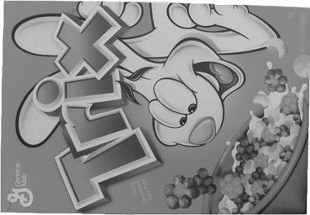
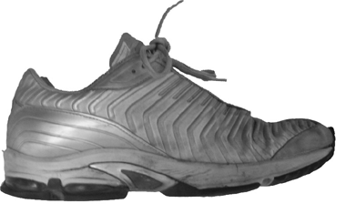
Figure 1: Two of our training images (front of Trix box and shoe)
The second step of image acquisition was to take a set of photographs of our objects in different environments. To be able to test the stability of our SIFT implementation, we needed images containing combinations of objects, occluded objects, differing object scales and orientations, and differing illumination conditions. We took images satisfying all of these criteria, although this image acquisition phase was not as scientific as we intended our final data set to be. We did not worry about details such as exact object angular orientation and distance for these images, as we had not yet gotten to the point in our project where such tests could begin. The images acquired did, however, give us a better idea of what types of images work well with SIFT features, and which do not.

After the pictures were taken, we put all our effort into understanding the Intel MATLAB code we had to start with. Soon, we realized that the code didn’t get further than finding feature points. Although the beginnings of a (rather confusing) keypoint descriptor generation function were there, this function looked incomplete and did not implement Lowe’s proposed method. Thus, in order to perform SIFT object recognition tests, the main hurdle would be to implement a keypoint descriptor generator. Luckily, we found out that Lowe himself had released a program named “Invariant Keypoint Detector,” which analyzes an input image and outputs a file containing the keypoint descriptors of the SIFT features found in that image. We assumed that this program implements the algorithm described in Lowe’s paper, although given the unavailability of the source code, we could not know for sure what it was doing. See Figure 3(a) for an example of the keypoints generated by the program for a particular scene image. Since we had obtained this program, we decided to have the two main elements of our implementation—keypoint generation and object recognition—proceed in parallel. In other words, we decided to start working on our own keypoint descriptor generator while at the same time using Lowe’s keypoints as input to object recognition code also in progress.

We started but did not quite finish our implementation of the SIFT keypoint generator. Our goal was to implement exactly the algorithm described in (Lowe, 2003) so that we could use it as a base of comparison for further changes. A long discussion with TA Daniel Russakoff was very helpful in figuring out exactly how Lowe’s algorithm works, and particularly in how it achieves rotational invariance.
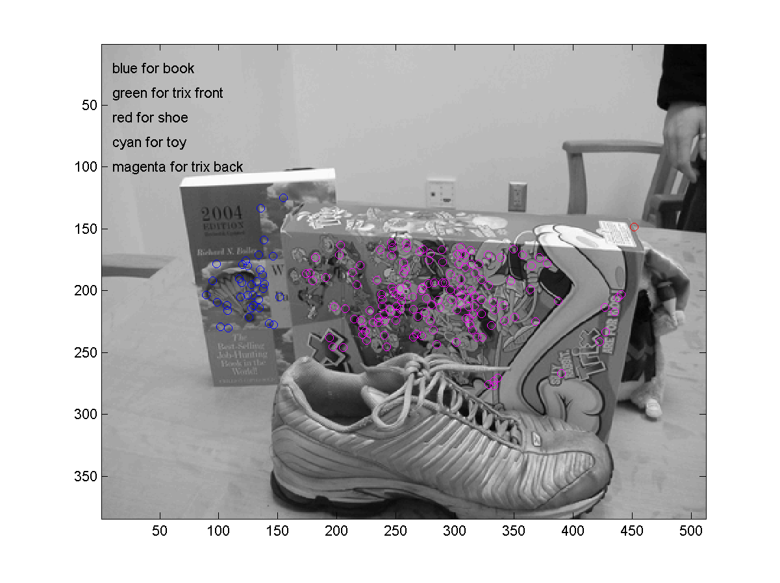
Figure 2: Off-angle image of the book, Trix box (back), and shoe. The book and Trix box have both been recognized, but that shoe has not.

Our work on the object recognition part of implementation also progressed during this period. To be able to test recognition on our scene photographs, we needed to construct a keypoint matching algorithm. This can be done in many different ways; an easy but inefficient approach is to find the Euclidian distance between a keypoint descriptor from the scene image and all the descriptors in the object database. The distances to the first and second closest matches are compared, and if the ratio between them is high, the probability of a correct match is also high. We implemented this method, but it turned out to be quite slow due to relying on expensive matrix operations within a ‘for’ loop. For increased efficiency, we wrote a new function with almost the same approach, but instead of calculating the Euclidian distance, we computed the scalar product between the keypoint descriptors in the scene image and those in the object database. Because this approach involves only one big matrix operation, it turned out to be around 20 times faster.

After debugging the basic matching code, we wrote functions to display the results of this first step in the object recognition process. We plotted all the matches as circles in the scene image, with different colors for matches to different objects in the database to give us a good idea of whether a particular match is correct or not. We experimented with parameters to see which values would maximize correct matches while minimizing incorrect ones. We found that using Lowe’s keypoint descriptors and our matching algorithm, flat, textured objects (such as the book and Trix box) are well-recognized, while more geometrically complex objects (such as the shoe and toy) are barely recognized at all. Figures 2 and 3 demonstrate this phenomenon. In Figure 2, the shoe (and toy) are not recognized, while in Figure 3, the Trix box is recognized even with rotation, occlusion, and a large specular highlight!

It was at about this point in our progress that we turned in our interim report. To our surprise, we found out several days after submitting the report that another group working with SIFT features had managed to acquire Lowe’s keypoint generation code! This revelation led us to Phase Two of our project…

Phase Two: Post Lowe-code

Since our MATLAB implementation of Lowe’s keypoint generation code was not yet finished (and quickly becoming hopelessly inefficient), our choice was clear: we decided to scrap our implementation and instead build off of Lowe’s code. The release of Lowe’s code marked a drastic shift in our project goals, as these goals had originally been formulated around the assumption that Lowe’s code was unavailable. Specifically, our goal of cleaning up and simplifying the algorithm was stymied upon seeing that Lowe’s code was actually quite clean and concise! Thus, we narrowed our project goals to include mainly implementing full object recognition (which the Lowe code does not do), and improving the lighting invariance of SIFT features using some suggestions of Gary’s.

Our main achievement during Phase Two was completing our implementation of Lowe’s object recognition algorithm. During Phase One, we had implemented basic feature matching, but we had not yet made progress on the two other steps of the algorithm: the Hough transform, and the solution for affine parameters. In the Hough transform step, the matched keypoint are clustered in their parameter space; clusters of keypoint matches that agree on the parameters of this space are selected, and outliers are discarded. We chose to use a three dimensional space, using object matched, scale, and orientation as our parameters. Our implementation of the Hough transform proved very effective in removing outliers (which do not belong to any cluster in parameter space).

The third step of Lowe’s object recognition algorithm solves for the parameters of the affine transformation for each object recognized using the previous two steps. The affine transformation is essentially the (approximate) mapping between the canonical object image stored in the recognition database and the object as it appears in the scene image. By using the mutual position and orientation of the keypoints in the scene image compared to the positions and orientations in the database, additional outliers can be removed as well. Finding the affine parameters made it possible to plot the database image above the object in the scene image, and in so doing bring out the object if it was occluded or distorted in some other way. Plotting the database image above the scene image also had the added benefit of showing us how well our object recognition algorithm was actually working.

The stages of object recognition can be seen in Figure 3. In 3(a), the raw output of Lowe’s keypoint generator is shown for a particular scene image. In 3(b), we have run our basic keypoint matching code using a five-image object recognition database. Note that while most keypoint matches are correct, there are some incorrect matches, both on and off objects in our database. In 3(c), we have run the Hough transform on the matches in 3(b); doing this has removed all incorrect matches. Finally, in 3(d), we
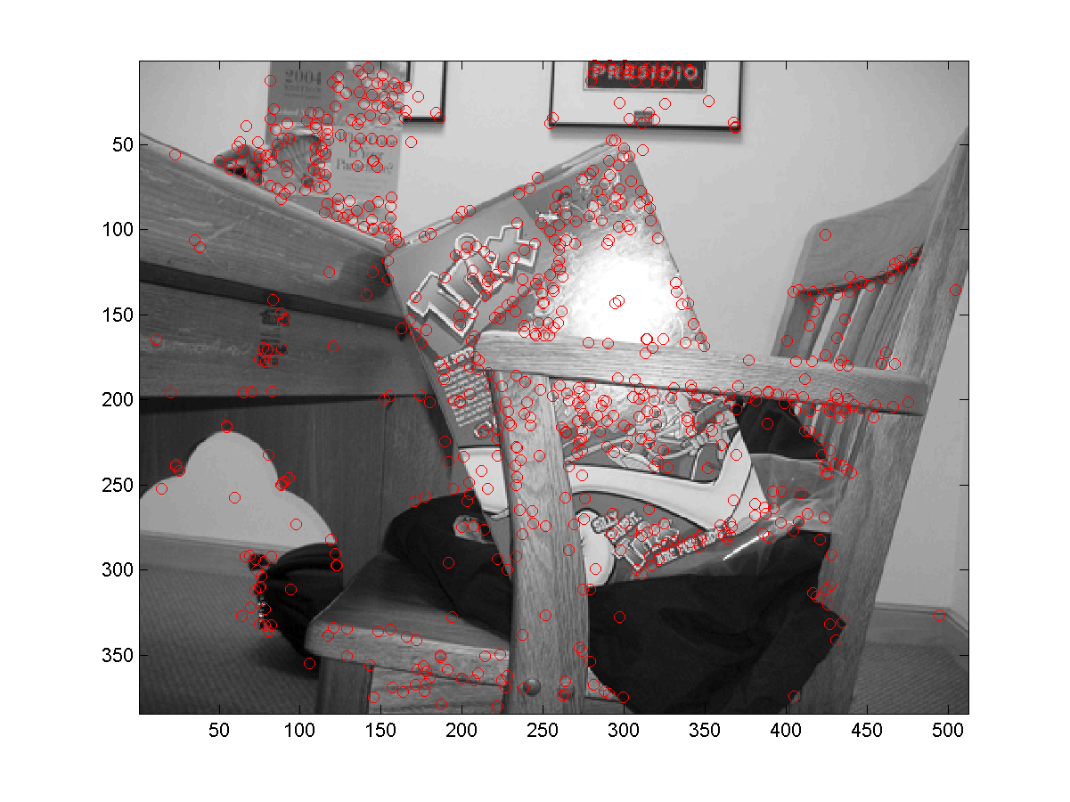
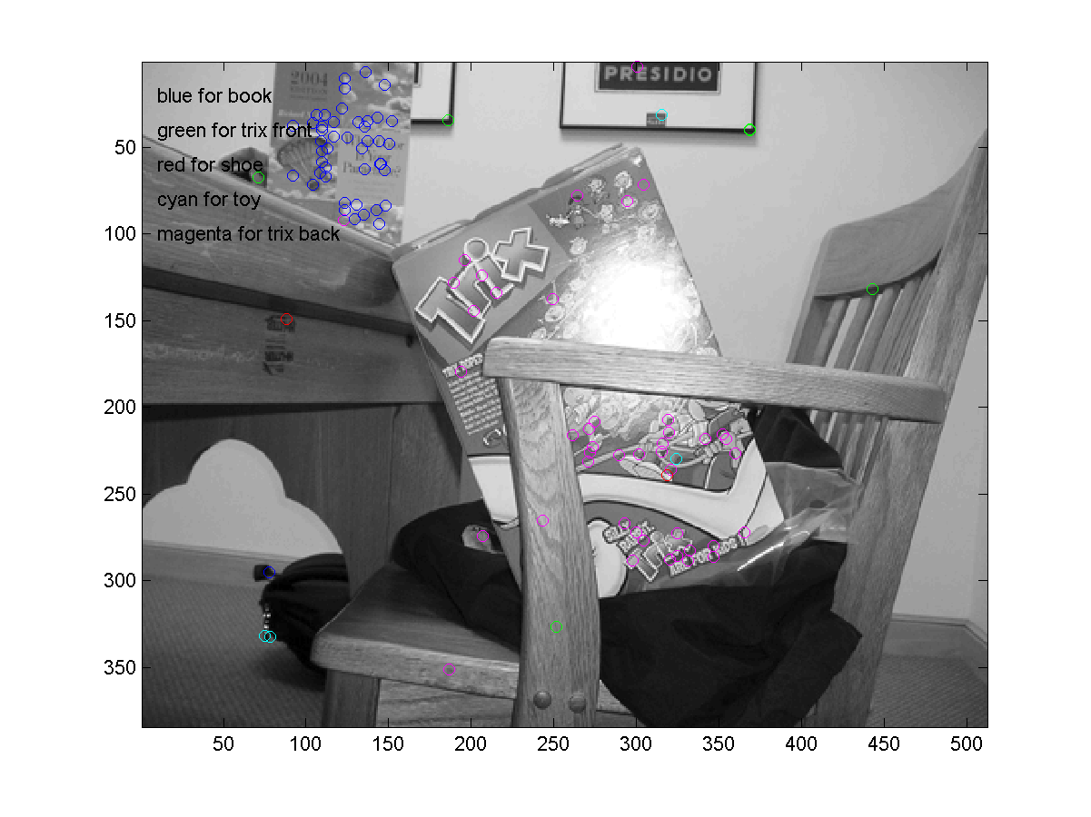
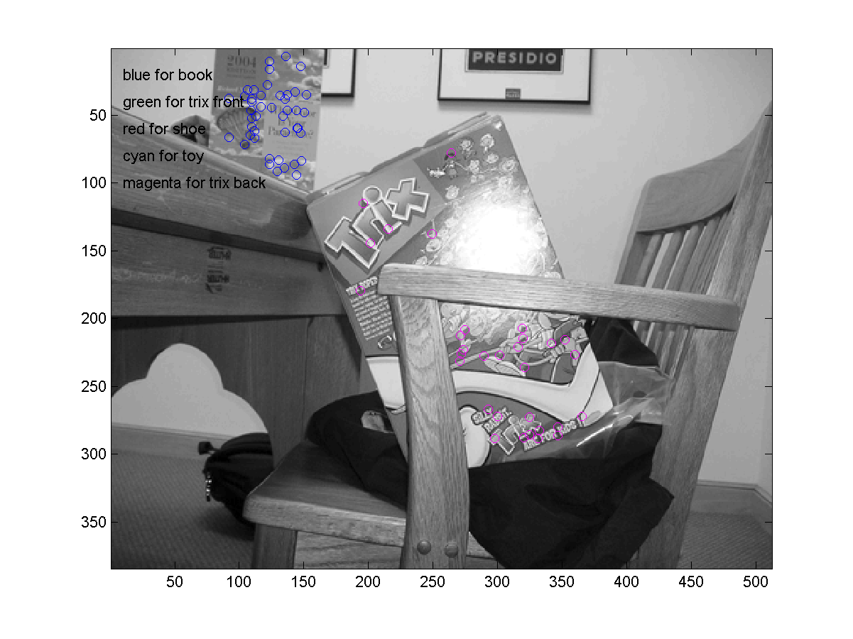
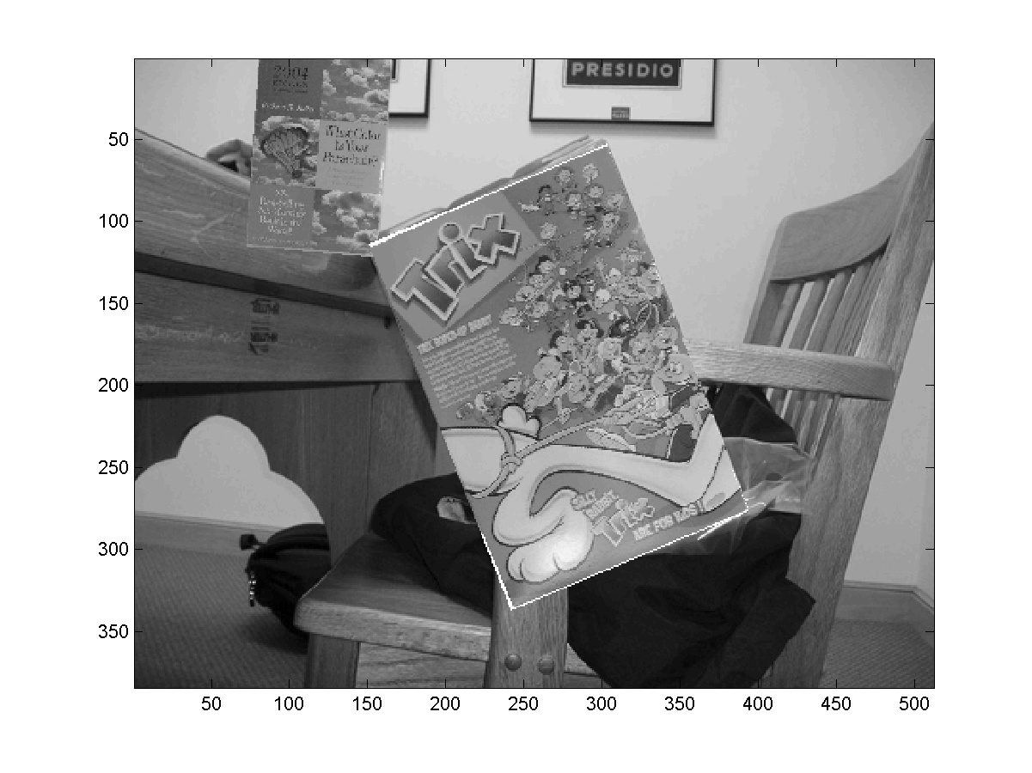
have solved for the affine parameters of the two recognized objects and overlaid our database images using these parameters. Both the book and the Trix box have been recognized to an impressive degree of precision.
Figure 3: (a) All keypoints detected by Lowe’s “Invariant Keypoint Detector.” (b) Valid keypoint matches to object database. (c) Remaining keypoints after hough transform. (d) Finally, the affine parameters are used to plot the database picture over the scene image.
(a)
(b)
(c)
(d)

During Phase Two, we also began experimenting with improving the lighting invariance of SIFT features. Gary suggested that during the formation of the pyramid of Difference of Gaussians images in Lowe’s algorithm, we normalize each Difference of Gaussians image with its corresponding Sum of Gaussians image. We implemented this alteration to the algorithm and tested it briefly, but we did not have enough time (before Phase Three) to determine conclusively what effect it was having on feature matching.

Our second major accomplishment in Phase Two was the formation of a much-improved set of scene images. Because we needed more precisely obtained images in order to exactly test any changes we made to Lowe’s algorithm, we took a second set of images, this time in a more “scientific” manner. We took three of our objects (the Trix box, the book, and the toy) and photographed them while varying three parameters: angle (we used 0°, 22.5°, 45°, and 67.5°), distance (we used 33, 66, and 150 inches) and illumination (we used indoor, sunny weather, and cloudy weather).

Before we got the chance to experiment with our newly acquired image database, however, the goals of our project were changed again in a meeting with Gary, this time even more drastically than before!
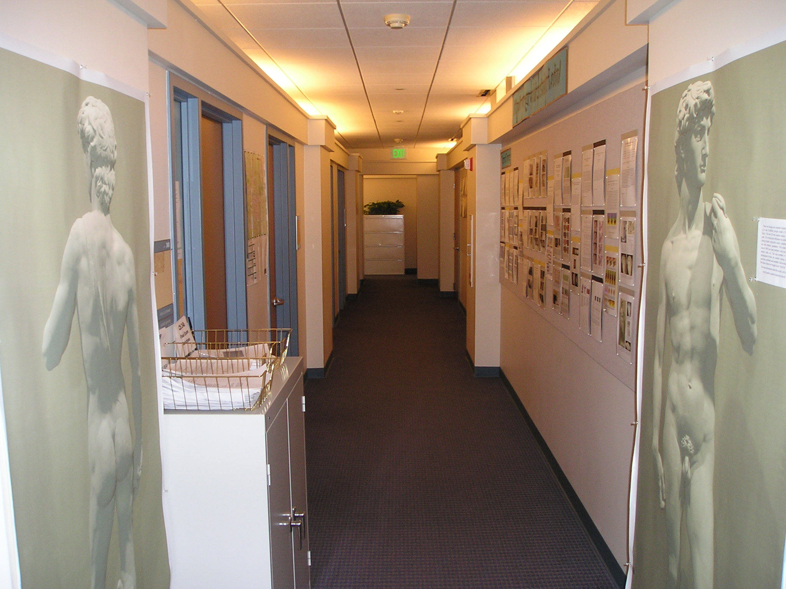
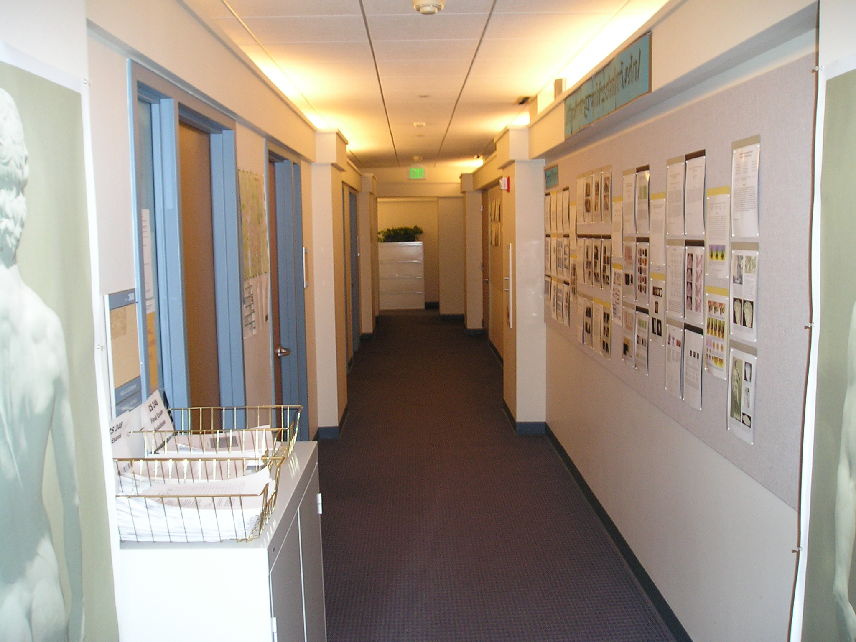
Figure 4: Two consecutive images of a hallway in the Stanford Graphics Laboratory.
Phase Three: Plane Finding

In a meeting on February 26th, Gary suggested a dramatic redirection of our project. This change was motivated by the unexpected release of Lowe’s keypoint generation code and the realization that contrary to expectation, it was actually quite concise and well-written. Gary suggested that our new goal (to be pursue to the end of this term and possibly in the future) should be to find the planes in a hallway using consecutive images taken while moving down that hallway. Lowe’s SIFT keypoint generation code would be used to find features in the hallway images, and these features would be matched to each other using the simple Euclidean distance scheme mentioned earlier.

Given that we had only one and one-half weeks before the project due-date we got to work immediately on this new project! Our first step was data collection: we took sequences of images moving down several hallways, trying to choose hallways containing lots of features SIFT could recognize. Although we made no attempt obtain these images precisely, the difference between any two of them is essentially a translation along the camera’s optical axis. The algorithm Gary suggested to us works on one image pair (at a time); one such pair is shown in Figure 4. For testing purposes, we also took images of the Trix box, as it was a simple planar object that, as we had found earlier, contained many features easily recognized and matched by the SIFT algorithm.

Gary suggested that in order to find the planes of the hallway using an image pair, we use a method involving RANSAC that involves finding and then refining planar homographies between sets of matching SIFT keypoints. This algorithm is explained in detail in the Approach section above. Our goal was to accurately find the homographies consistent with an image pair and then to convert these homographies to the parameters of their corresponding planes. We finished the first step of this process, although with some issues; however, due to several problems and lack of time have not yet finished the conversion of homographies to planes (which would have aided in visualization).

We got the homography detection process working reasonably well. See Figure 5 for an example of our results. In 5(a), all the keypoints matched between two consecutive hallway images are shown (only one of the images is pictured). In 5(b), the sets of keypoints found to agree with a specific planar homography are shown color-coded; four planes have been found, although two (namely the left-hand wall) are rather sparse in features. We experienced several problems in implementing and testing the plane-finding algorithm. First, the algorithm is very instable, and its various input parameters must be tweaked quite heavily to yield useful results. We think that the biggest problem with the algorithm is the way in which it obtains initial guesses of homographies in the RANSAC step. We tried forming guesses using random keypoints as well as keypoints in the vicinity of each other, but each method (especially the first), often leads to wildly incorrect “best” guesses being formed through the RANSAC process. The problem seems to lie partially in the fact that (perhaps due to the sparsity of keypoints), for certain planes, the guessed keypoints will never lie fully on one plane. The iterative refining stage also often offers no help, converging to a homography that agrees with enough points on the image (within error bounds), but does not correspond to an actual image plane. We also realized during testing that the camera we used to take hallway images was not well calibrated at all. We noticed that significant radial distortions were occurring in our images, which were causing single planes often to be recognized as multiple planes patched together. This phenomenon was especially evident in a test picture of the Trix box, in which the floor under the box was recognized as several connected planes near the edges of the image. Although one would think raising the error threshold would fix (or help) this problem, doing so only further revealed the instability of the algorithm, causing it to find all sorts of false planes in the image.

We spent the better part of several days trying to convert our found homographies to plane parameters for the purpose of visualization, but we have not yet been successful in doing so. We implemented a technique from one paper that failed, and tried futilely to understand the vague algorithm description presented in another paper, before talking for a while with TA Daniel Russakoff. He eventually suggested an algorithm involving the algorithm for “uncalibrated stereo” in Trucco and Verri which sounded like it would work, but we did not have enough time to produce its rather involved implementation.

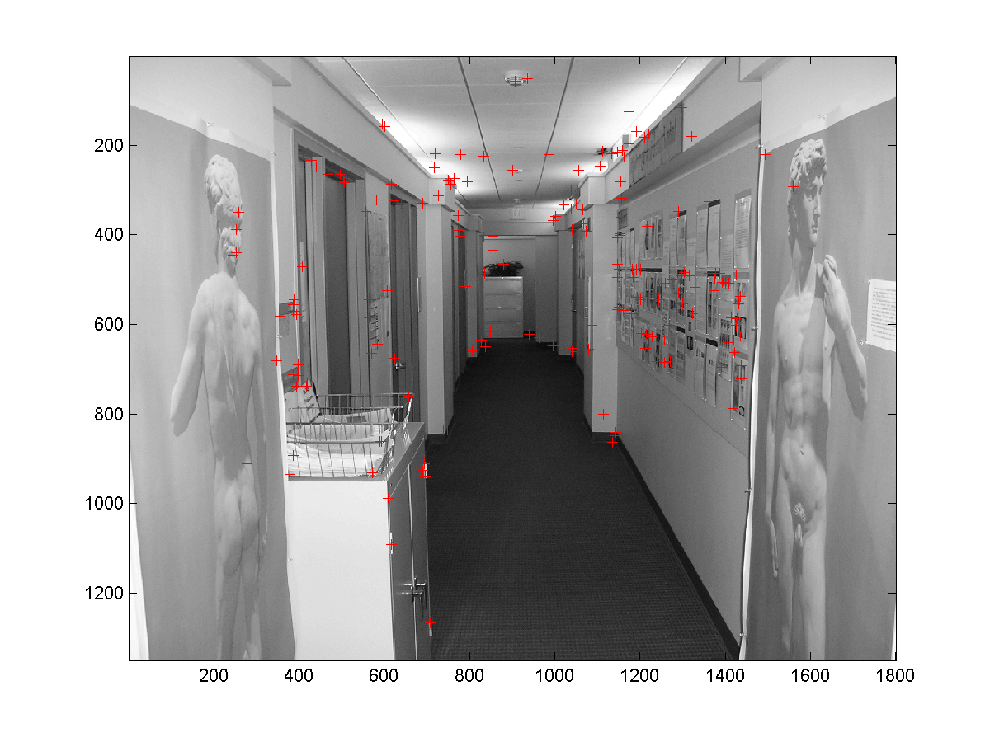
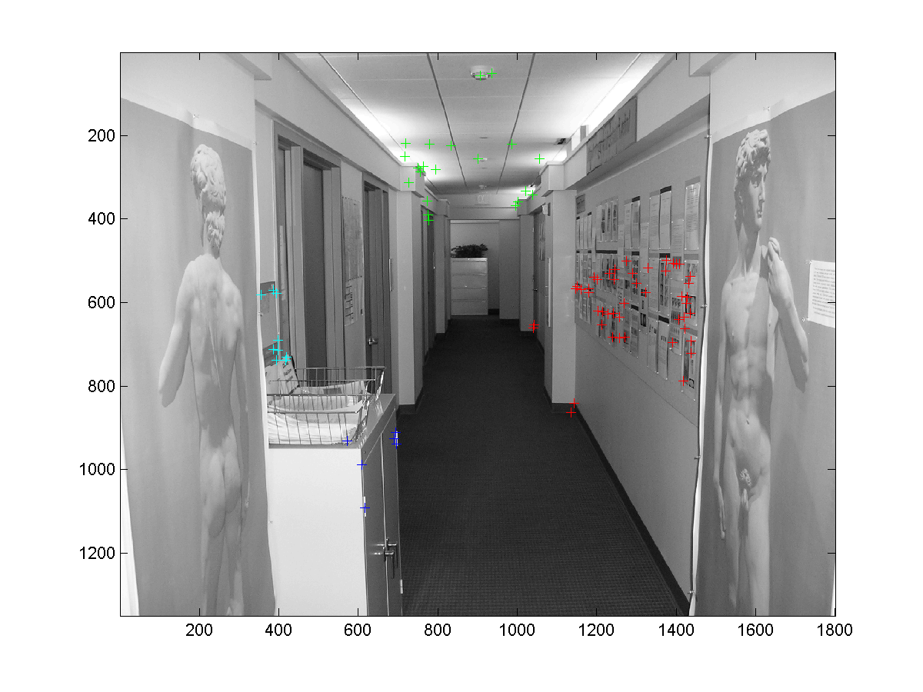
Figure 5: (a) The keypoints matched between two consecutive hallway images. (b) The groups of point found to agree with specific planar homographies are shown color-coded (four planes have been found).
(a)
(b)
Related Work

SIFT features

David Lowe first introduced the SIFT algorithm for scale-invariant feature detection and object recognition in (Lowe 1999). Lowe has argued for the effectiveness of SIFT features by showing their similarity to biological processes. The SIFT algorithm was refined and expanded upon in (Lowe, 2003).

A considerable amount of research has been done in identifying representations that are invariant to scale change. Crowley and Parker (1984) developed a representation that identified peaks and ridges in scale space, Shokoufandeh, Marsic, and Dickinson (1999) have provided more distinctive feature descriptors using wavelet coefficients, and Lindeberg (1993, 1994) has dealt with the problem of scale selection, which assigns a consistent and appropriate scale to each feature. Lowe’s SIFT algorithm uses the idea of detecting local oriented features in scale space, which was first shown to be effective in Christoph von der Malsburg’s use of oriented Gabor filters over different scales linked in a graph.

Mikolajczyk and Schmid (2003) have shown that of several currently used interest point descriptors, SIFT descriptors are the most effective.

Plane detection

The method Vincent and Laganiere (2001) describe for detecting planar homographies in an image pair is very similar to our approach. Instead of using SIFT features, they run a corner detection algorithm to locate all the corners in both images and then match up corner points exhibiting a sufficiently high correlation. They use a RANSAC and iterative refinement scheme that is quite similar to ours.

We attempted to reconstruct the actual plane equations of planes in our scene images using the planar homographies output from our algorithm, but we have not yet been successful in this endeavor. Rother, Carlsson, and Tell (2002) have developed an algorithm to derive the three-dimensional plane equations from the planar homographies between images of the same scene taken from the different perspectives. The key idea they employ is to designate one plane (visible from all views) as the plane at infinity. Xu, Terai, and Shum (2000) outline a very powerful linear algorithm that can obtain using two planar homographies between two images the equations of the planes, the rotation and translation between the two cameras, and the focal lengths of the cameras.

Conclusion

The initial goal of our project was to implement, simplify, and improve Lowe’s SIFT algorithm for object recognition. Because Lowe’s code has now been released, and because of its concision and clarity, this goal is now largely obsolete. Our implementation of Lowe’s three-stage object recognition algorithm (which was not included in the released code) and the database of testing images we created do still remain useful, however.

The second goal of our project—to detect planes in hallway image pairs using SIFT features—remains quite viable. Our initial progress of finding the planar homographies contributes to this goal (and helps demonstrate the utility of SIFT features for this purpose). Many issues remain to be resolved however, and much further work can be done in this area. First of all, as we have explained in the Results section, we suspect that the basic algorithm that we have used is fundamentally limited in its effectiveness for plane detection. It is possible that more feature matches between images would have alleviated this problem, however. Even if the same algorithm is used, more work could certainly be put into making it more robust. One notable further direction of research is to use spectral clustering of the homography matrices found during the RANSAC stage of the algorithm to find and combine like planes.

References

Crowley, J. L. and Parker, A.C. 1984. A representation for shape based on peaks and
ridges in the difference of low-pass transform. IEEE Trans. on Pattern Analysis
and Machine Intelligence, 6(2):156-170.
Lindeberg, T. 1993. Detecting salient blob-like image structures and their scales with a
scalespace primal sketch: a method for focus-of-attention. International Journal
of Computer Vision, 11(3):283-318.
Lindeberg, T. 1994. Scale-space theory: A basic tool for analysing structures at different
scales. Journal of Applied Statistics, 21(2):224-270.
Lowe, D.G. 1999. Object recognition from local scale-invariant features. In
International Conference on Computer Vision, Corfu, Greece, pp. 1150-1157.
Lowe, D.G. 2003. Distinctive image features from scale-invariant keypoints. Draft
submitted for publication.
Mikolajczyk, K., Schmid, C. 2003. A performance evaluation of local descriptors.
Proceedings of the 2003 IEEE Computer Society Conference on Computer Vision
and Pattern Recognition.
Rother, C., Carlsson, S., and Tell, D. 2002. Projective factorization of planes and cameras
in multiple views. In ICPR 2002, Quebec, Canada, pp. 737-740.
Shokoufandeh, A., Marsic, I., and Dickinson, S.J. 1999. View-based object recognition
using saliency maps. Image and Vision Computing, 17:445-460.
Vincent, E, and Laganiere, R. 2001. Detecting planar homographies in an image pair. In
Proc 2nd International Symposium on Image and Signal Processing and Analysis, Pula, Croatia, pp. 182-187.
Xu, G, Terai, J. and Shum, H. 2000. A linear algorithm for Camera Self-Calibration,
Motion and Structure Recovery for Multi-Planar Scenes from Two Perspective Images. In CVPR, Hilton Head Island, South Carolina, pp. 474-479.

