Interim Report: Improving SIFT Features

Michael Turitzin, Anthony Hui, and Christer Gustavsson
(Project Coordinator: Gary Bradski)

Abstract

The Scale Invariant Feature Transform (SIFT) was introduced by David Lowe in (Lowe, 1999). SIFT is a method for extracting distinctive invariant features from images that can be used to perform reliable matching between different images of the same object or scene. Because of its computational efficiency and effectiveness in object recognition, the SIFT algorithm has led to significant advances in computer vision. The goal of our project is essentially to clean up, simplify, and improve Lowe’s SIFT algorithm (as described in (Lowe, 1999 and 2003)). We intend first to implement the algorithm roughly as Lowe has defined it and then to make changes to it, gauging their effectiveness in object recognition. Specifically, we intend to improve SIFT’s robustness to illumination changes, which will be judged by recognition accuracy in various outdoor scenes. We hope in general to improve the effectiveness of SIFT recognition keys by experimenting with different keypoint descriptor generation methods, trying to maximize recognition scores with varying cameras and illuminations. We will be creating an image database along the way to test our implementation of and changes to the algorithm.

Introduction / Our Approach

The major problem with SIFT is that the algorithm is not crisply defined and has lots of free parameters; information provided by the Lowe’s papers is sometimes vague and not complete, and thus leaves lots of implementation details to be filled in. Unfortunately, there is no source code available to show how the algorithm is really implemented, so we must do the implementation on our own using incomplete code from Intel as a base. We seek to clarify SIFT’s ambiguities by replicating the algorithm in MATLAB and then making further improvements to the code.

In a nutshell, Lowe’s algorithm finds stable features over scale space by repeatedly smoothing and downsampling an input image and subtracting adjacent levels to create a pyramid of difference-of-Gaussian images. The features the SIFT algorithm detects represent minima and maxima in scale space of these difference-of-Gaussian images. At each of these minima and maxima, a detailed model is fit to determine location, scale and contrast, during which some features are discarded based on measures of their (in)stability. Once a stable feature has been detected, its dominant gradient orientation is obtained, and a keypoint descriptor vector is formed from a grid of gradient histograms constructed from the gradients in the neighborhood of the feature. Keypoint matching between images is performed using a nearest-neighbor indexing method, followed by a Hough transform that finds keypoints that agree on potential object poses, and finally a solution for affine parameters, which determines the specific location and orientation of each recognized object.

There are many points along the course of this algorithm where simplifications and potential improvements can be made. Our current goals, beyond implementing and testing Lowe’s algorithm, are (1) to simplify and clean up the algorithm as much as possible, (2) improve lighting invariance by normalizing potential SIFT difference-of-Gaussian points with the sum-of-Gaussians, and (3) improve the general stability of keypoints. To accomplish these goals, we have begun an image database which will be used to test the effectiveness of our modifications.

Thus far, we have created a sizable database of both training and scene images. The objects in our training images have been segmented from the background for use in recognition. We have read the SIFT papers to learn Lowe’s algorithm as well as the extensions and improvements that have been made to it in the years since its inception. We have started implementing Lowe’s gradient histogram SIFT feature keys and have made some progress but are not quite yet ready to test them. Using Lowe’s publicly available “Invariant Keypoint Detector” program (source not provided), we have generated a database of keypoints for several of our objects from our training images. In order to test SIFT’s object recognition capabilities, we have implemented a simple version of the nearest-neighbor keypoint matching method Lowe describes, which calculates and compares the Euclidean distances between keypoints in our database. Results of this work can be seen in the “Current Results” section.

Background

(some sections borrowed/paraphrased from (Lowe, 2003))

The development of image matching by using a set of local keypoints can be traced back to the work of Moravec (1981) on stereo matching using a corner detector to select interest points. The Moravec detector was improved by Harris and Stephens (1988) to make it more repeatable under small image variations and near edges. The Harris corner has since been widely for many other image matching tasks. While these feature detectors are usually called corner detectors, they are not selecting just corners, but rather any image location that has large gradients in all directions at a particular scale.

Zhang et al. (1995) showed that it was possible to use Harris corners over a long image range by using a correlation window around each corner to select likely matches. At the same time, a similar approach was developed by Torr (1995) for long-range motion matching. Schmid and Mohr (1997) showed that invariant local feature matching could be extended to general image recognition problems in which a feature was matched against a large database of images. They also used Harris corners to detect interest points, but rather than matching with a correlation window, they used a rotationally invariant descriptor of the local image region. This allowed features to be matched under arbitrary orientation change between the two images. Furthermore, they demonstrated that multiple feature matches could accomplish general recognition under occlusion and clutter by identifying consistent clusters of matched features. However the Harris corner is very sensitive to changes in image scale, so it does not provide a good basis for matching images of different sizes.

A considerable amount of research has been done in identifying representations that are invariant to scale change. Crowley and Parker (1984) developed a representation that identified peaks and ridges in scale space, Shokoufandeh, Marsic, and Dickinson (1999) have provided more distinctive feature descriptors using wavelet coefficients, and Lindeberg (1993, 1994) has dealt with the problem of scale selection, which assigns a consistent and appropriate scale to each feature. Lowe’s SIFT algorithm uses the idea of detecting local oriented features in scale space, which was first shown to be effective in Christoph von der Malsburg’s use of oriented Gabor filters over different scales linked in a graph. Mikolajczyk and Schmid (2003) have shown that of several currently used interest point descriptors, SIFT descriptors are the most effective.

Current Results

Before we could get started with image recognition, we needed a set of images to work with. We divided the image acquisition process into two parts: photographing and segmenting training images of our objects, and photographing a variety of scenes containing them.

We first photographed training images of several objects in order to create an object recognition database. We used the following objects: a book, a box of Trix cereal (front and back), a soft toy, a moderately-reflective laptop (closed), and a shoe. We chose these objects based on the complexity of their geometry, amount surface texture, reflectivity, and rigidity. Since these images comprise our first set, we tried to use objects that would be relatively easy to detect (more on that later). We intend to photograph more complex objects such as humans once our implementation of SIFT becomes fully functional. Each object was photographed once (with the exception of the Trix box) from what we decided was the “canonical” orientation. Because we were taking training images, we needed good lighting conditions to make a object features clearly visible and a monochromatic background to ensure that all keypoints in the images actually belonged to the objects. We accomplished this by taking our photographs inside in a well-lit room and placing the objects in front of a neon-green background. The colored background made it easy later to segment the object from the background in Photoshop. See Figure 1 (figures at the end of the report) for examples of our training images.

The second step of image acquisition was to take a set of photographs of our objects in different environments. To be able to test the stability of our SIFT implementation, we needed images containing combinations of objects, occluded objects, differing object scales and orientations, and differing illumination conditions. We took images satisfying all of these criteria, although this image acquisition phase was not as scientific as it will need to be when we begin testing our SIFT implementation. We did not worry about details such as exact object angular orientation and distance for these images, as we have not yet gotten to a point in our project where such tests can begin. The images acquired are, however, giving us a better idea of what types of images work well with SIFT features, and which do not.

After the pictures were taken, we put all our effort into understanding the Intel MATLAB code we had to start with. Soon, we realized that the code didn’t get further than finding the feature points. Although the beginnings of a (rather confusing) keypoint descriptor generation function were there, this function looked incomplete and did not implement Lowe’s proposed method. Thus, in order to perform SIFT object recognition tests, the main hurdle would be to implement a keypoint descriptor generator. Luckily, we found out that Lowe himself has released a program named “Invariant Keypoint Detector,” which analyzes an input image and outputs a file containing the keypoint descriptors of the SIFT features found in that image. Presumably, this program implements the algorithm as described in Lowe’s papers, although since the source is unavailable, we have no way of knowing for certain what it is doing. See Figure 2 for an example of the keypoints generated by the program for a particular scene image. Since we had obtained this program, we decided to have the two phases of implementation—keypoint generation and object recognition—proceed in parallel. In other words, we decided to start working on our own keypoint descriptor generator while at the same time using Lowe’s keypoints as input to object recognition code also in progress.

Our work on the keypoint descriptor generator has been progressing, although it is not yet ready for testing with object recognition. We are trying to implement exactly the algorithm described in (Lowe, 2003) so that we can use it as a base of comparison for further changes. A long discussion with TA Daniel Russakoff was very helpful in figuring out exactly how the algorithm works, and particularly in how it achieves rotational invariance. We have also learned that due to all the details and sub-pixel nature of the algorithm, it will be difficult to implement efficiently in MATLAB.

Our work on the object recognition part of implementation has also been progressing. To be able to test recognition on our scene photographs, we needed to construct a keypoint matching algorithm. This can be done in many different ways; an easy but inefficient approach is to find the Euclidian distance between a keypoint descriptor from the scene image and all the descriptors in the object database. The distances to the first and second closest matches are compared, and if the ratio between them is high, the probability of a correct match is also high. We implemented this method and it has given us good results, but it also turned out to be quite slow due to relying on expensive matrix operations within a ‘for’ loop. For increased efficiency, we wrote a new function with almost the same approach, but instead of calculating the Euclidian distance, we computed the scalar product between the keypoint descriptors in the scene image and those in the object database. Because this approach involves only one big matrix operation, it turned out to be around 20 times faster.

After debugging the basic matching code, we wrote functions to display the results of this first step in the object recognition process. We plot all the matches as circles in the scene image, with different colors for matches to different objects in the database. This gives us a good idea of whether a particular match is correct or not. See Figure 3 for an example of matching using a small object database. We experimented with parameters to see which values would maximize correct matches while minimizing incorrect ones. Some of our keypoint matching results are illustrated in the images below. We have found that using Lowe’s keypoint descriptors and our matching algorithm, flat, textured objects (such as the book and Trix box) are well-recognized, while more geometrically complex objects (such as the shoe and toy) are barely being recognized at all. Figures 3, 4, and 5 demonstrate this phenomenon. In Figures 3 and 4, the toy and shoe are not recognized, while in Figure 5, the Trix box is recognized even with rotation, occlusion, and a large specular highlight! Since we are currently finding exact Euclidean distances (rather than the approximations Lowe uses for efficiency in his “Best Bin First” algorithm), these results suggest two possible causes: either there is something wrong with our training images (or we have picked bad objects or scenes to test with), or Lowe’s keypoint generation program is flawed. If the latter is the case, it will be interesting to see how our code fares once we have finished it and are able to perform tests.

Next Steps

We still have to complete the following tasks:

- Get our keypoint descriptor generation code up and running. Once we have done this, testing and improvements to the Lowe algorithm can begin in full.
- Finish the object recognition part of the implementation. This will involve several steps: first, possibly improving the efficiency of our keypoint matching algorithm by implementing Lowe’s “Best Bin First” algorithm (this will be necessary if our keypoint recognition database grows large, although it is currently running quickly for several objects); second, implementing the Hough transform for potential object matches to determine which matches agree with each other on object pose; and finally, solving for affine parameters to determine the exact position and orientation of recognized objects.
- Use a more scientific approach to obtain a second set of training and scene images. This will allow us to exactly test our algorithms stability under varying image parameters.
- Simplify and modify the keypoint descriptor generation algorithm, testing to see which changes are beneficial and which are not. In particular, we hope to achieve better illumination invariance than Lowe’s algorithm provides. We intend to compare our results to those obtained using Lowe’s “Invariant Keypoint Detector,” particularly to figure out why Lowe’s program is currently having such a hard time detecting the shoe and toy objects.
- In general, perform tests on various images to gauge the strengths and weaknesses of our implementation of keypoint generation. Test with different object angular orientations, scales, occlusions, and indoor and outdoor lighting conditions.
- Optimize and clean up our code to make it more usable.

References

Crowley, J. L. and Parker, A.C. 1984. A representation for shape based on peaks and
ridges in the difference of low-pass transform. IEEE Trans. on Pattern Analysis
and Machine Intelligence, 6(2):156-170.
Harris, C. and Stephens, M. 1988. A combined corner and edge detector. In Fourth
Alvey Vision Conference, Manchester, UK, pp. 148-151.
Lindeberg, T. 1993. Detecting salient blob-like image structures and their scales with a
scalespace primal sketch: a method for focus-of-attention. International Journal
of Computer Vision, 11(3):283-318.
Lindeberg, T. 1994. Scale-space theory: A basic tool for analysing structures at different
scales. Journal of Applied Statistics, 21(2):224-270.
Lowe, D.G. 1999. Object recognition from local scale-invariant features. In
International Conference on Computer Vision, Corfu, Greece, pp. 1150-1157.
Lowe, D.G. 2003. Distinctive image features from scale-invariant keypoints. Draft
submitted for publication.
Mikolajczyk, K., Schmid, C. 2003. A performance evaluation of local descriptors.
Proceedings of the 2003 IEEE Computer Society Conference on Computer Vision
and Pattern Recognition.
Moravec, H. 1981. Rover visual obstacle avoidance. In International Joint Conference
on Artificial Intelligence, Vancouver, British Columbia, pp. 785-790.
Schmid, C., and Mohr, R. 1997. Local grayvalue invariants for image retrieval. IEEE
Trans. On Pattern Analysis and Machine Intelligence, 19(5):530-534.
Shokoufandeh, A., Marsic, I., and Dickinson, S.J. 1999. View-based object recognition
using saliency maps. Image and Vision Computing, 17:445-460.
Torr, P. 1995. Motion Segmentation and Outlier Detection, Ph.D. Thesis, Dept. of
Engineering Science, University of Oxford, UK.
Zhang, Z., Deriche, R., Faugeras, O., and Luong, Q.T. 1995. A robust technique for
matching two uncalibrated images through the recovery of the unknown epipolar
geometry. Artificial Intelligence, 78:87-119.

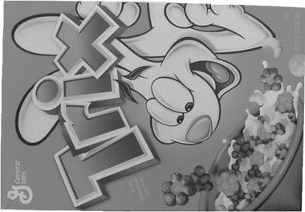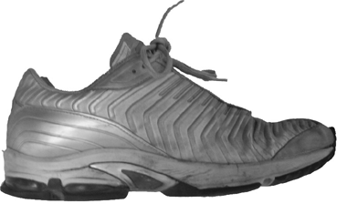

Figure 1: Two of our training images (front of Trix box and shoe)
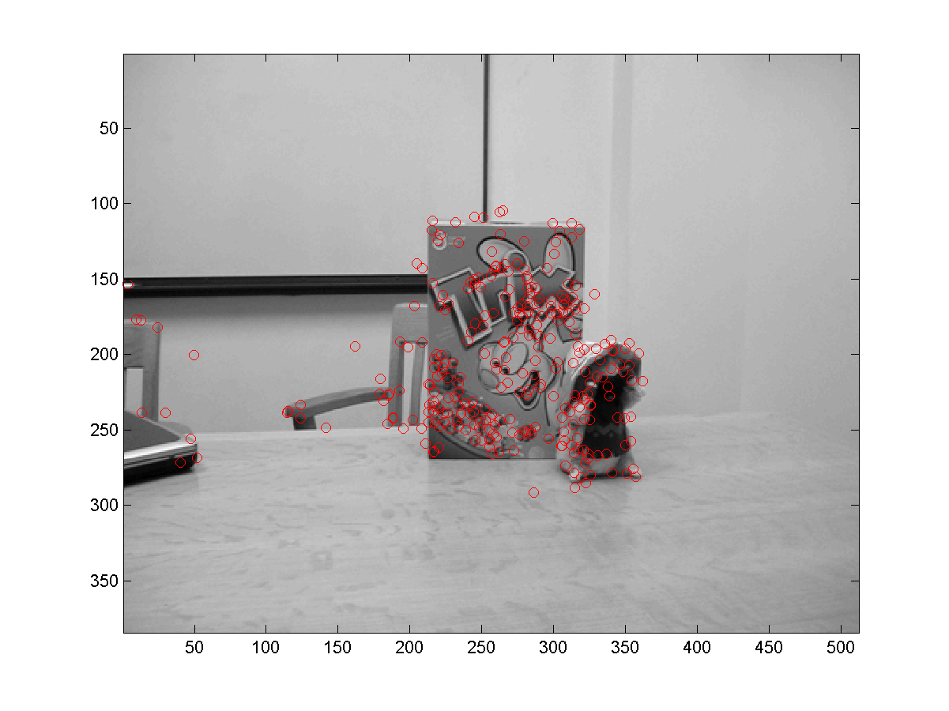
Figure 2: All keypoints detected by Lowe’s “Invariant Keypoint Detector
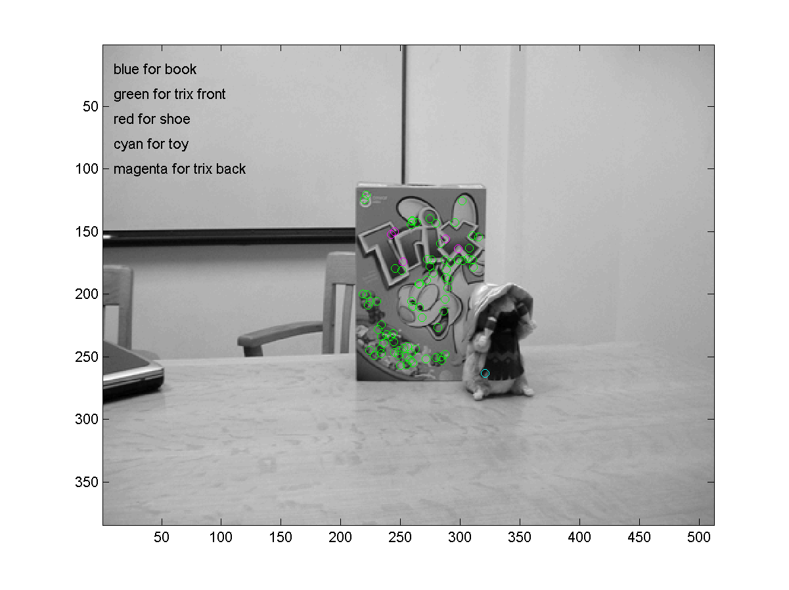
Figure 3: Same image as in Figure 2. Keypoint matching has been run with a 5 image recognition database. Notice that the front of the Trix box has been mistaken for the back at a few points (unsurprising since the logo is duplicated), and also that the toy has not been recognized at all.
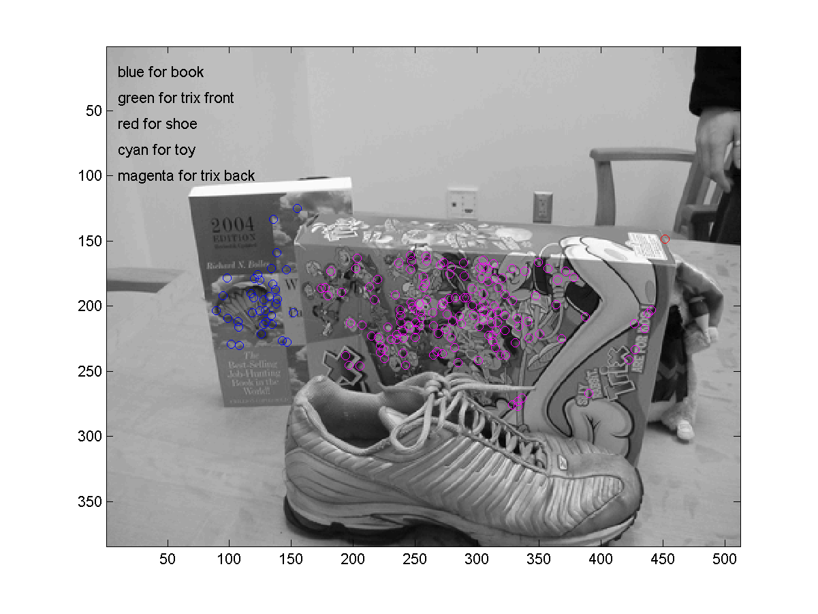
Figure 4: Off-angle image of the book, Trix box (back), and shoe. The book and Trix box have both been recognized, but that shoe has not.
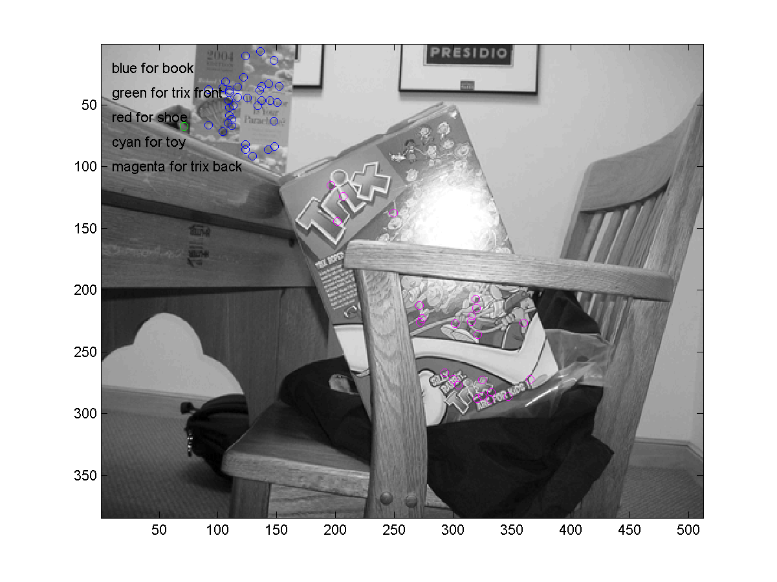
Figure 5: Image of Trix box (back) and book (in upper-left corner). Both objects have been recognized. In the case of the Trix box, this is despite occlusion and a large specular highlight.

